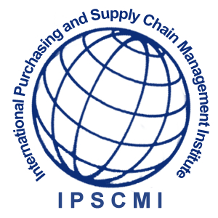
ADMISSIONS OFFICE  
International Purchasing and
Supply Chain Management Institute

Admission Application

16192 Coastal Highways,
Lewes, Delaware, 19958
Tel: (302) 570-0886
Fax: (415) 651-8884
E-Mail: admin@ipscmi.org
Web Site: www.ipscmi.org

INSTRUCTIONS
Please provide the information requested. You may submit this application by email or by fax. Admission is
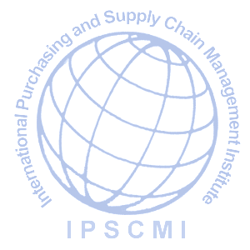
granted without regard to race, gender, handicap or nationality.
Last Name: First Name:
Address:
Home Phone: Work phone: Fax No.:
E-Mail:
Birthplace: Birth Date: Month Day Year Sex: □ Male □ Female
Planned Program Start Date:
Objective □CISCM □CISM □CIPP/CIPM/CIPC □CPP/CPPM □CICCM □Other (Name):

EDUCATIONAL INSTITUTIONS ATTENDED
List in order, (first to last) all educational institutions you have attended or are now attending. Begin with elementary school, Junior high school, Senior high, College or University; give exact dates of attendance, and the name of each degree/ diploma/certificate awarded in English.

Name of Institution | City & Country | Dates of Attendance  From To | Name of Certificate  or Degree Awarded

I hereby certify that all statements made hereon are true and correct to the best of my knowledge and authorize the verification of all statements herein recorded by the International Purchasing and Supply Chain Management Institute in processing my application.

Applicant’s Signature Date Signed

